Annual ABE Grant Application Workshop (Spring Regionals 2020)
Presentation slides are available at: mnabe.org/state-abe-presentations

ABE Grants and Applications
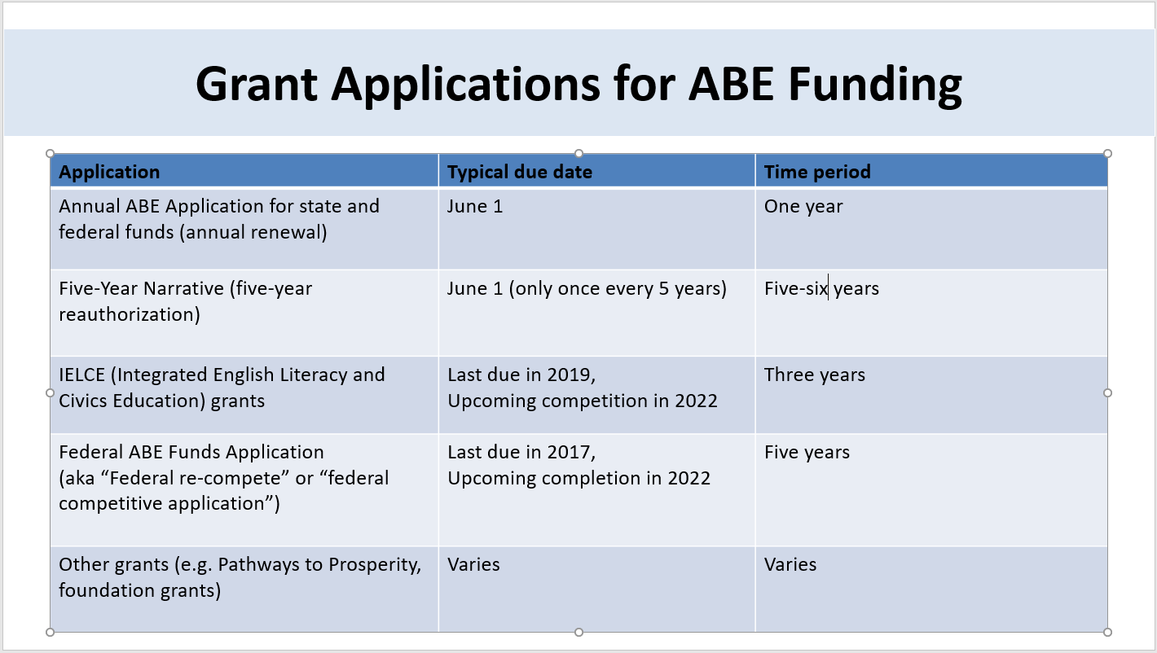
5-year narratives
- 2020 narratives due June 1, 2020
- 2021 narrative writing consortia must participate in review:
  - Narrative Review Session on Thursday, June 25, 2020 at MDE
  - Narrative Writers Workshop on Tuesday, Sept 29, 2020 at MDE
IELCE
- Current grantees are in year 1 of 3 year grant
- Current grantees will submit an annual report due July 30
- Next competition will be Spring 2022.
Federal competitive application
- Next competition will be Spring 2022 (no 5-year narratives that year)
- In that competition all ABE providers (not just fiscal agent or consortium as a whole) will be required to “demonstrate effectiveness” by providing performance data on:
  - Improving participants’ academic skills
  - Participant outcomes with diplomas, transitions to post-secondary and employers
- Tips to be prepared:
  - Make sure SiD is organized so data can be pulled for each provider separately
  - Consider how to track information not currently required in SiD, such as students getting jobs and students accepted into college
Annual ABE application
- CHANGE THIS YEAR: Grant application documents only be available to individuals with an EDIAM (Education Identity and Access Management) account. Watch for additional guidance on this from the MDE-ABE office when the application documents are posted in April.
- Annual application process:
  - Download documents from MDE website
  - Complete two documents:
    - Application (Microsoft Word)
    - Tables A, 7, 13, B (Excel)
      - NOTE: You must type data from SiD into Microsoft Excel document
  - Upload into SERVS
  - Authorized signer must (virtually) sign by June 1 deadline
    - Typically superintendent or executive director
- Application due June 1, 2020 at 3:30 pm in SERVS
- Be sure your authorized signer is aware of this due date and their role in submitting the application.

ABE Finance
State and Federal ABE Funding:
Remember that unspent federal ABE funding rolls back into the statewide pot of funding for the following year, while unspent state funding is lost to our system. For this reason it’s better to leave federal funds unspent than state funds.
For discussion with your business office:
- Are expenditures on track with the budget?
- How much state and federal funds are remaining?
- Will all those funds be spent by the end of the fiscal year?
- If all funds can’t be spent, how can we make sure state funds are spent down first, to avoid losing them?

