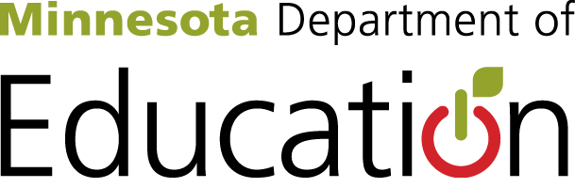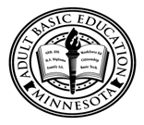

New State Adult Diploma Local Pilot Implementation Tool
In each area, check off what is already complete in your program. For areas that are not complete, write in what is needed and when this area might be complete.

Section 1: Standards
Standards | Staff Reviewed | Staff Trained | Programming Articulated | Programming Launched | Needs and Next Steps
English Language Arts (CCRS)
Mathematics
(CCRS, MN K-12)
Science (MN K-12)
Social Studies (MN K-12)
Employability, Career Development
(ACES TIF)
Digital Literacy
(Northstar Digital Literacy)

Section 2: Staffing
Role | Staff Roles Articulated | Training | Resources Ready | Launching Pilot in Role | Needs and Next Steps
Administer diploma pilot program

Intake

Assessment

Credit/ experience verification

Initial advising

Personal Learning Plans

Ongoing advising

Final graduation advising

Reading instruction

Writing instruction

Listening & speaking instruction

Math instruction

Science instruction

Social studies instruction

Employability & career development skills instruction

Digital literacy instruction

Online Portfolio Support

Other Technology Support

Other?

Section 3: Programming
Programming | Resources/ Tools Identified, Developed and/or Obtained | Aligned to Policies and/or Standards | New Programming Developed | Launching | Needs and Next Steps
Intake

Assessment

Credit/experience verification

Initial advising

Personal Learning Plans

Ongoing advising

Final graduation advising

Reading instruction

Writing instruction

Listening & speaking instruction
Math instruction

Science instruction

Social studies instruction

Employability & career development skills instruction

Digital literacy instruction

Other?

Section 4: Program Procedures
Area | Local Policies Developed | Local Procedures Articulated | Local Programming Launched | Needs and Next Steps
Intake and Eligibility

Advising

Personal Learning Plans

Credit & Experience Verification

Assessment

Onsite Student Competency Verification

Instruction

Student Learner Web Portfolios

Graduating Advising Session
Other?

Big Questions
Document your pilot program’s questions here.

