Minnesota’s New State Adult Diploma

Defining the new state adult diploma
Minnesota’s new state adult high school diploma is a standard competency-based diploma that is issued by the state department of education for adults that complete an approved ABE program.
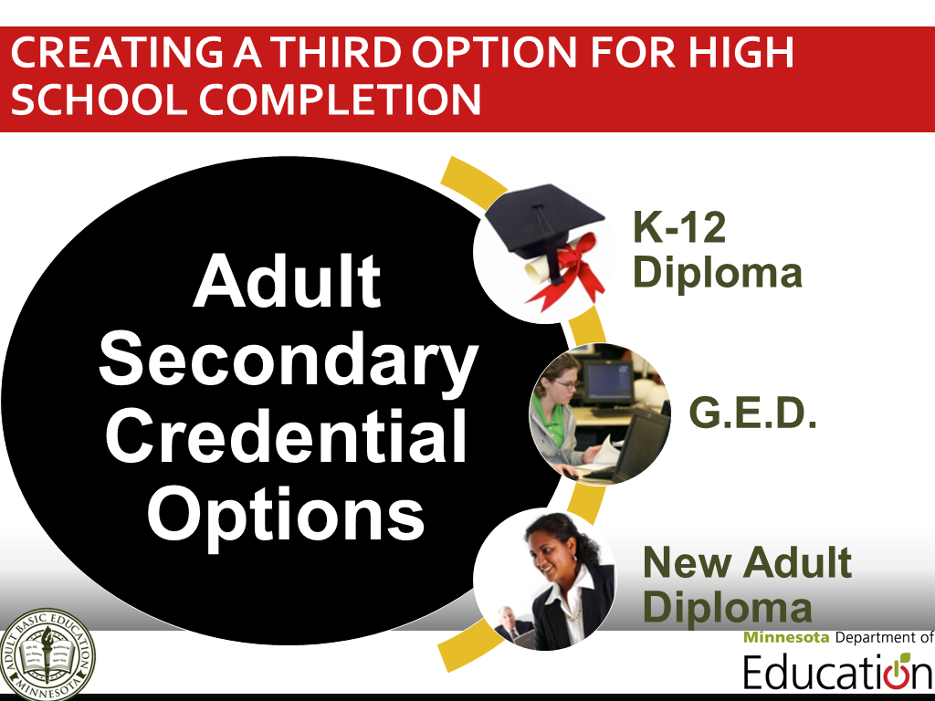

Aligning to Minnesota’s educational standards
Competencies for the Minnesota State Adult Diploma are based on Minnesota’s current K-12 graduation standards and embed:
- College and Career Readiness Standards (CCRS) for Adult Education
- Academic, Career and Employability Skills (ACES) Transitions Integration Framework and
- Northstar Digital Literacy Standards

Minnesota State Adult Diploma Competency Domains
- English Language Arts
- Mathematics
- Career Development and Employability Skills, including Digital Literacy Skills
- Social Studies
- Science

Guiding adult students to success through advising, instruction & evaluation
Initial Advising Session
- Identify student goals
- Assess student skills and experience to determine what competencies that may already be complete for the transcript based on prior learning competency verification
- Identify potential career pathway(s) and needs using career and postsecondary preparation assessments, similar to assessments used in Minnesota’s K-12 system
- Develop an individualized learning plan based on the student’ identified goals and skills

Instruction and Evaluation
- Implement individualized learning plan based on instruction and preparation on the competency domains.
- Post-test learners using approved assessments for Minnesota’s ABE programming
- Track progress towards diploma and goals
- Update and adapt individualized learning plan
- Provide additional support services

Graduating Advising Session
- Evaluate students’ work in Adult Diploma Program to ensure completion of necessary competencies
- Create transitions plan to students’ future goals

Adult students demonstrate their skills
Adult diploma students may successfully complete each competency through one of the following ways:
- Prior Experience-Based Competency Verification (K-12, postsecondary or other experiences)
- Test-Verified Knowledge (approved standardized assessment for high schools, secondary credentials, ABE programs and/or postsecondary entrance exams)
- ABE Course Demonstration (classes that combine academic, college and career content, like special adult diploma classes, GED preparation, Accuplacer classes, college readiness classes, subject-specific classes, FastTRAC programming, etc.)
- Applied and Experiential Learning (through an approved project, like the National External Diploma Program.)

Making the State Adult Diploma available across Minnesota
Initial Development | May-October 2014
Pilot Phase One | November 2014-June 2015
Pilot Phase Two | July 2015-December 2016

Collaboratively leading implementation
Primary entities developing the state adult diploma and aiding local implementation with approved Adult Basic Education (ABE) consortia include the Minnesota Department of Education, an adult diploma working group and a new consultation team.

Where to find more information
- Read Minnesota State Statute 124D.52 (Subd. 8-9)
- Contact Brad Hasskamp at brad.hasskamp@state.mn.us or (651) 582-8594

New State Adult Diploma Pilot Programs

13 consortia applications were accepted and selected to pilot the new state standard adult high school diploma.
- Cass Lake-Bena-Walker ABE
- Central Minnesota ABE (St. Cloud)
- Department of Corrections (St. Cloud and Faribault facilities)
- Hiawatha Valley ABE (Red Wing)
- Lakeville ABE
- Metro North ABE (Blaine)
- Minneapolis Adult Education (Volunteers of America)
- Osseo ABE
- Robbinsdale Adult Academic Program
- Rochester ABE
- Southeast ABE (Faribault)
- Southwest ABE Region Collaborative (Mankato, New Ulm, BIC Graphics/Sleepy Eye, Hutchison, Willmar, LeSueur, St. Peter, Marshall, Worthington, Granite Falls, and Blue Earth)
- St. Paul Community Literacy Consortium (Hubbs Center)

New State Standard Adult High School Diploma Program Timeline
- Pilot Application Release Date (Wednesday, November 5, 2014)
- Pilot Application Due Date (Tuesday, December 2, 2014)
- Initial Training (Monday, December 15, 2014, Thursday, January 15, 2015, and Friday, January 16, 2015)
- Pilot Period (February 2 – June 30, 2015)
- Working Group Meeting (3rd Monday of the month)
- End of pilot period (June 30, 2015)
- Local Pilot Evaluation/Report Due (July 15, 2015)
- Evaluate pilot period and prepare for full launch (June-August 2015)
- Post application for pilot phase 2 (October 2015)
- Pilot 2 applications due (November 2015)
- Pilot 2 initial training – 2nd Monday/month (January-June 2016)
Ongoing training and technical assistance will be provided through the monthly New State Adult Diploma Working Group, which meets typically the third Monday of the month.

Student Eligibility
An adult can be eligible for this diploma program if they do not have a diploma, are not participating with K-12 services, are age 19 and older, and are eligible for ABE program services.

State Standard Adult High School Diploma Pilot Program Details
Applicant | Pilot Sites | Pilot Lead | Contact Information
Cass Lake-Bena-Walker | Cass Lake-Bena &  Walker | Sarah Larson | 218-335-6529
Central Minnesota | St. Cloud Discovery Center | Scott Wallner | 320-529-6500
DOC | St. Cloud and Faribault facilities | Theresa Luther-Dolan | Theresa.Luther@state.mn.us
Hiawatha Valley | Red Wing/Southeast Technical College | Jill Rivard | 651-385-4562
Lakeville | Pathways Adult Education  Lakeville Area Learning Center (Downtown Lakeville) | Clifford Skagen | 952-232-2080
Metro North | Blaine Learning Lab (Co-location with the Anoka County Workforce Center) | Patrice Adams | 763-783-4870
Minneapolis | Volunteers of America Adult High School | Kate Ronald | 612-375-0700
Osseo | Osseo ABE Center | Julie Pierce | 763-566-5452
Robbinsdale | Adult Academic Program - Sandburg Learning Center, Golden Valley | Theresa Zingery | 763-504-8300
Rochester | Hawthorne Education Center | Nadine Holthaus | 507-328-4440
Southeast | Faribault | Yesica Louis | 507-333-6473
Southwest ABE Region | Lincoln Community Center (Mankato), New Ulm Workforce Center (Mankato), BIC Graphics (Sleepy Eye), Hutchison ABE site, Willmar ABE site, SW ABE sites (Marshall, Worthington, Granite Falls, Pipestone), AALC sites (LeSueur, St. Peter), Faribault County ABE site (Blue Earth) | Karen Wolters | 507-345-5222
St. Paul Community Literacy Consortium | Hubbs Center for Lifelong Learning | Renada Rutmanis | 651-744-7611
Total | 26+ Sites

For More Information
Contact Brad Hasskamp at brad.hasskamp@state.mn.us or (651) 582-8594

