# Minnesota’s New State Adult Diploma

## Defining the new state adult diploma

Minnesota’s new state adult high school diploma is a standard competency-based diploma that is issued by the state department of education for adults that complete an approved ABE program.

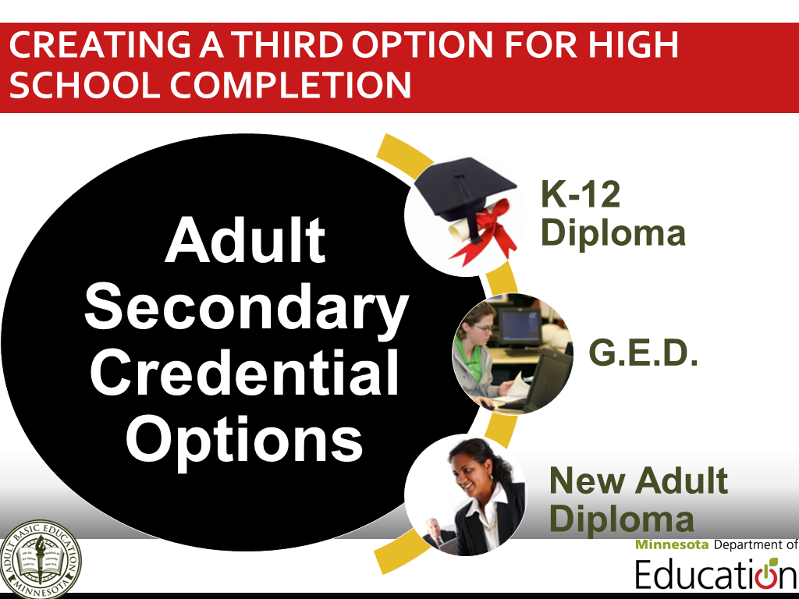

## Aligning to Minnesota’s educational standards

Competencies for the Minnesota State Adult Diploma are based on Minnesota’s current K-12 graduation standards and embed:

* College and Career Readiness Standards (CCRS) for Adult Education
* Academic, Career and Employability Skills (ACES) and
* Northstar Digital Literacy Standards

## Minnesota State Adult Diploma Competency Domains

1. English Language Arts
2. Mathematics
3. Career Development and Employability Skills, including Digital Literacy Skills
4. Social Studies
5. Science

## Guiding adult students to success through advising, instruction & evaluation

**Initial Advising Session**

1. Identify student goals
2. Assess student skills and experience to determine what competencies that may already be complete for the transcript based on prior learning competency verification
3. Identify potential career pathway(s) and needs using career and postsecondary preparation assessments, similar to assessments used in Minnesota’s K-12 system
4. Develop an individualized learning plan based on the student’ identified goals and skills

**Instruction and Evaluation**

1. Implement individualized learning plan based on instruction and preparation on the competency domains.
2. Post-test learners using approved assessments for Minnesota’s ABE programming
3. Track progress towards diploma and goals
4. Update and adapt individualized learning plan
5. Provide additional support services

**Graduating Advising Session**

1. Evaluate students’ work in Adult Diploma Program to ensure completion of necessary competencies
2. Create transitions plan to students’ future goals

## Adult students demonstrate their skills

Adult diploma students may successfully complete each competency through one of the following ways:

* **Prior Experience-Based** **Competency Verification** (K-12, postsecondary or other experiences)
* **Test-Verified Knowledge** (approved standardized assessment for high schools, secondary credentials, ABE programs and/or postsecondary entrance exams)
* **ABE Course Completion** (classes that combine academic, college and career content, like special adult diploma classes, GED preparation, Accuplacer classes, college readiness classes, subject-specific classes, FastTRAC programming, etc.)
* **Applied and Experiential Learning** (through an approved project, like the National External Diploma Program.)

## Making the State Adult Diploma available across Minnesota

|  |  |
| --- | --- |
| **Initial Development** | *May-October 2014* |
| **Pilot Phase One** | *November 2014-June 2015* |
| **Full Launch** | *July 2015-ongoing* |

## Collaboratively leading implementation

Primary entities developing the state adult diploma and aiding local implementation with approved Adult Basic Education (ABE) consortia include the **Minnesota Department of Education**, an **adult diploma working group** and a new **consultation team**.

## Where to find more information

* Read Minnesota State Statute 126D.52 (Subd. 8-9)
* Contact Brad Hasskamp at [brad.hasskamp@state.mn.us](mailto:brad.hasskamp@state.mn.us) or (651) 582-8594