Data and Accountability
2019 Fall ABE Manager Meeting

Key Topics
- Outcomes, Targets and Reports
- Report Card and Program Improvement
- Assessment Updates
- SiD Highlights

Outcomes, Targets and Reports
Minnesota Adult Education Statistics 2019
58,984 enrollees
- 2,880 had not attended any education before
- 5,538 were incarcerated
- Roughly 3,000 diplomas earned
4,465,601 contact hours
- 172,604 were distance learning
1,496 paid staff
2,697 volunteers
333 sites
Minnesota ABE’s 2018-19 WIOA Outcomes
Measure | Statewide (2018) | Statewide (2019)
Measurable skill gain | 39.73% | 42.56%
Employment at second quarter after exit | 33.87% | 37.59%
Employment at fourth quarter after exit | 33.44% (partial) | 33.54%
Median quarterly earnings at second quarter after exit | $5,583 | $5,660
Credential Attainment Plus (and Entering Postsecondary or Employment) | 12.4% (partial) | 22.88%
Measurable Skill Gains (MSG)
There are multiple Ways to Count MSG. (Only one type of gain will be counted for each participant per period.)
- Earn higher scores on approved pre- and post tests to advance to a higher level
- Earn a secondary credential (high school or equivalency diploma) by June 30
- Enter postsecondary education (only after participant exits ABE) by June 30
Targets for Measurable Skills Gains
The U.S. Department of Education sets a target for MSGs for each state.
The Minnesota Department of Education applies the same target for all ABE consortia.
The targets set a goal for the percent of all ABE participants that earn an MSG.
Super Targets (2019-2020)
- 44% of participants in ABE levels should earn a MSG
- 44% of participants in ESL levels should earn a MSG
Coming Soon: New Accountability Targets
- Measurable skill gain
- Employment at second quarter after exit*
- Employment at fourth quarter after exit*
- Median quarterly earnings at second quarter after exit*
- Credential Plus (Postsecondary or Employment)*
*There may be federal targets for these measures starting July 2020 for 2020-2021.
Credential Attainment Plus Indicator
Two Ways to Show Success:
- Diploma + Employment/Postsecondary: Earns a high school or equivalency diploma, exits the ABE program and is either employed or enrolled in a postsecondary education or training program within one year of exit.
- Co-enrollment + Postsecondary Credential: Co-enrolled in ABE and postsecondary and earns a recognized postsecondary credential (may be in IET program).
Coming 2020: Report Training Costs
By August 1, 2020, we are going to ask each consortium please report:
- ABE students receiving training services with state and federal ABE funding (number served and number exited); and
- Amount of state and federal ABE money you spent on training services for ABE students.
Training services, costs, and IET will be further defined and clarified with state ABE office and Minnesota WIOA partners.
Spring 2022: Federal Competitive Application
USED requires competition for ABE providers regularly, as stated in WIOA plan.
This means no 5-year narratives due in 2022.
All providers must “Demonstrate Effectiveness” by providing performance data on:
- Improving participants’ skills in reading, writing, mathematics, and English language; and
- Participant outcomes with employment, diplomas, and transitions to postsecondary education and training.
Who is an ABE Provider?
- All entities within a consortium that use ABE funding to provide ABE instruction (including the fiscal agent/grantee) are ABE providers.
- Note: In the upcoming federal competitive application, ALL ABE providers will need to demonstrate effectiveness, not just the consortium overall or just the fiscal agent.

Report Card and Program Improvement
The MNABE Report Card shows results for ABE consortia across the state and includes data on:
- Measurable Skills Gains
- Post-testing Rates
- Retention and Persistence
- Revenue
MNABE Report Cards: Program Improvement
The MNABE Report Card also identifies ABE consortia for Program Improvement.
Program Improvement Flags
ABE consortia are required to participate in Program Improvement in 2019 if:
- Measurable Skill Gains (Level Gains and Diplomas) for ABE students fell below 30%;
- Measurable Skill Gains (Level Gains and Diplomas) for ESL students fell below 30%; and/or
- Post-testing rate for students who have 40+ hours fell below 60%
Program Improvement Process 2019-2020
What do consortia in Program Improvement have to do?
- One-day Program Improvement Workshop in November
- Program Improvement planning
- Technical assistance from MDE
Program Improvement Cohort divided into two groups:
Group one includes consortia whose level gains rates in either ESL or ABE fell between 27% and 30%, or were only flagged on the post-testing rates measure.
- Required to complete a Program Analysis Worksheet and participate in a day-long Program Improvement Workshop
- Encouraged but not required to complete Program Improvement planning with technical assistance from MDE
Group two includes consortia whose level gains rates in either ABE or ESL fell below 27%.
- Required to complete a Program Analysis Worksheet, participate in a day-long Program Improvement Workshop, and complete Program improvement planning with technical assistance from MDE
Program Improvement Process 2020 and beyond
- Data from program year 19-20 will be reported on the 2020 MNABE Report Card in early fall of 2020, kicking off the next Program Improvement cycle.

Assessment Updates
CASAS GOALS updated Test Administration Manual
- Make sure your program is using the 2nd edition of the CASAS GOALS Test Administration Manuals for both Reading and Math.
- More information can be found at www.casas.org.
TABE 11/12 Testing Times
- New maximum allowable testing times available at www.tabetest.com.
Test Survey Due November 22 extended to December 6.
- We want to know:
  - NRS assessments used;
  - test format (paper/pencil scored by hand, paper/pencil scored by scanner, online);
  - testing resources developed;
  - successes and challenges with online testing; and
  - interest in bulk purchase of online tests.
- Email sent November 20 to consortium manager. Managers can forward to others.

SiD Highlights
Class names and Adult Literacy Hotline
- We are working towards the state Adult Literacy Hotline on MLC website integrating info from SiD automatically.
- Hotline Reminder - Keep subsite info up to date. Your subsite classes, addresses, and contact info will populate the hotline.
- Hotline Display info - edit in SiD under Hotline Tab.
- New MLC Hotline - populated from SiD (hotline.mnabe.org)
From 3 to 1-month data lockdown?
- Testing and attendance data has a three-month lockdown in SiD.
- MDE, Urban Planet and SPARC are discussing the possibility of a 1-month lockdown for testing and attendance data.
- Why a one-month data lockdown? Benefits:
  - Adheres to best practice in timely data entry
  - Makes preparing data for the June and August submissions easier for programs
  - Allows MDE to pull accurate statewide data more frequently
New Level Gains By Demographics Report

Barriers to Employment
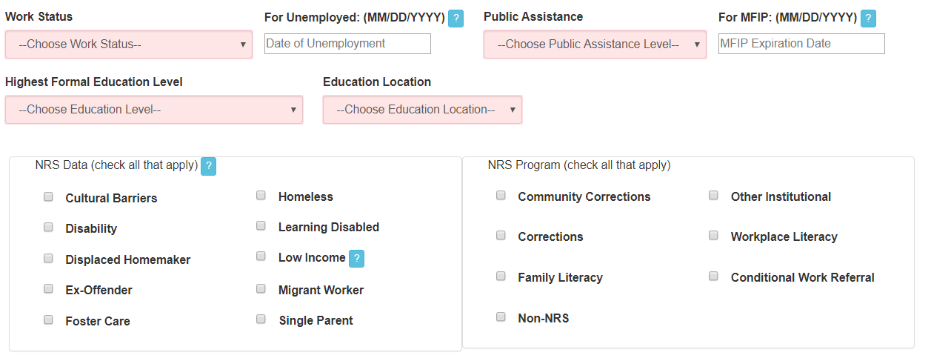
Please obtain and record students’ barriers to employment.
If Unemployed, add date student became unemployed.
Work-Focused Credentials in SiD
- Minnesota Certified Food Manager
- Job Ready Assessment - Culinary Arts Level One- Prep Cook
- Carpenter Level One
- OSHA 10-hour Certifications
- Internet & Computing Core (IC3) Digital Literacy Certification
- Microsoft Office Specialist (MOS) Certifications
- Child Development Associate (CDA) Credential
- ParaPro Assessment
- Nursing Assistant Registered /Certified Nursing Assistant
- Home Health Aide
- Personal Care Assistant
- Phlebotomy Technician Certification
- The Community Interpreter: The International Edition (TCII)
- ServSafe Certification
- A+ Certification
- IT Fundamentals Certification
- Emergency Medical Technician (EMT) Basic Certification
- NIMS Credential - Machining Level 1 - Measurement, Materials, & Safety
- AWS Certified Welder or Robotics
- IPC-A-610, Acceptability of Electronic Assemblies
- Job Ready Assessment - Retail Merchandising
- RISE UP-Retail Industry Fundamentals
- First Aid and CPR/AED - Bloodborne Pathogens Training
Enter Student Credentials Earned in Student History.
Coming soon: 40-hour waiver
Waiver for 40-hour restriction on post-testing ONLY when a student plans to exit the ABE program AND has completed a course of study AND/OR is ready to complete a secondary, college-ready or occupational assessment or credential.
Examples:
- 12-hour Accuplacer Prep Course
- 20-hour Intensive GED Prep Course
- 30-hour Commercial Drivers License Prep Course
Available by December 1.
Add in comments:
- Who approved the waiver and
- Name of secondary/college-ready/occupational assessment or credential.
Data on waiver use added to desk monitoring report and to state monitoring.

