Minnesota ABE Accountability 101
Version: August 9, 2018

Accountability Measures in WIOA
The Workforce Innovation and Opportunity Act of 2014 outlines six different accountability measures for ABE programs and other WIOA title programs:
  - Measurable skill gain
  - Employment at second quarter after exit*
  - Employment at fourth quarter after exit*
  - Median earnings at second quarter after exit*
  - Credential earned (and Entering Postsecondary or Employment)*
  - Employer engagement**
Aggregated performance outcomes analyzed statewide, by consortium, by category of individuals facing barriers to employment, and by age, gender, and race.
*These measures will apply for ABE programs starting in 2020.
**This measure is not yet full defined nor being measured for ABE programs.
Multiple Ways to Count Measurable Skill Gain (MSG)
(Only one type of gain will be counted for each participant per period)
1. Earn higher scores on approved pre- and post tests to advance to a higher level
2. Earn a secondary credential (high school or equivalency diploma) by June 30
3. Enter postsecondary education (only after participant exits ABE) by June 30
4. Participants in “adult high school” can complete Adult Basic Education
(ABE) Level 5 by earning enough Carnegie Units or credits to move to 11th- or 12th-grade status*
(*Not yet applicable for ABE in Minnesota)

Minnesota ABE Core Federal Performance Targets
Targets for Measurable Skill Gain (MSG)
NRS Educational Functioning Level and Core Indicator Goals | MN FY 2017  (2016-17) |  |  | FY 2019  (2018-19) | FY 2020  (2019-20)
 | % Completing Each Level/Goal |  |  | % Earning Measurable Skill Gain | % Earning Measurable Skill Gain
 | Target | MN Actual | U.S. Actual | Target | Target
ABE 1: ABE Beginning Literacy | 78 | 60 | 48 | 61 | 61
ABE 2: ABE Beginning Basic Education | 67 | 48 | 45 | 48 | 48
ABE 3: ABE Intermediate Low | 50 | 41 | 42 | 43 | 43
ABE 4: ABE Intermediate High | 34 | 37 | 42 | 40 | 41
ABE 5: Low Adult Secondary | 26 | 29 | 52 | 46 | 52
ABE 6: High Adult Secondary | N/A** | 28 | 42 | 36** | 42**
ESL 1: ESL Beginning Literacy | 48 | 45 | 44 | 45 | 45
ESL 2: ESL Beginning Low | 58 | 56 | 50 | 56 | 56
ESL 3: ESL Beginning High | 51 | 46 | 50 | 47 | 51
ESL 4: ESL Intermediate Low | 39 | 39 | 45 | 42 | 45
ESL 5: ESL Intermediate High | 35 | 35 | 39 | 37 | 37
ESL 6: ESL Advanced | 16 | 23 | 24 | 25 | 26

* Starting with the 2016-2017 data, ABE data is slowly evolving to adhere to the new WIOA accountability system, which is slightly different than previous data measures. Full WIOA accountability expectations will be implemented by 2020.
**For ABE 6, the only way to earn a measurable skill gain is through completion of a high school or equivalency diploma or to exit ABE and enter postsecondary education and training.

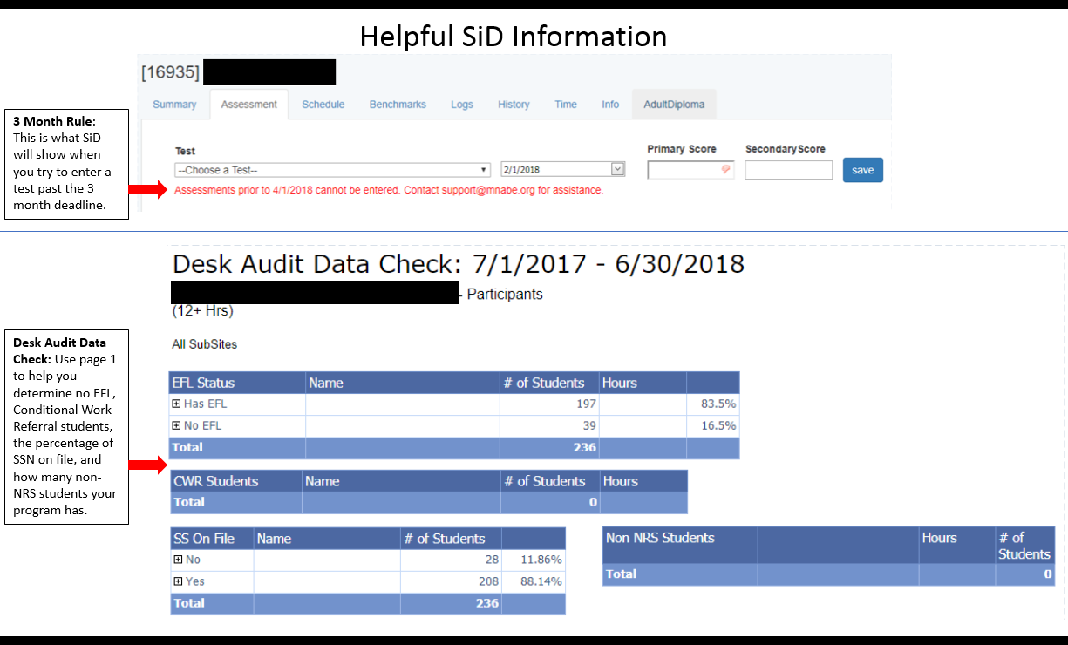
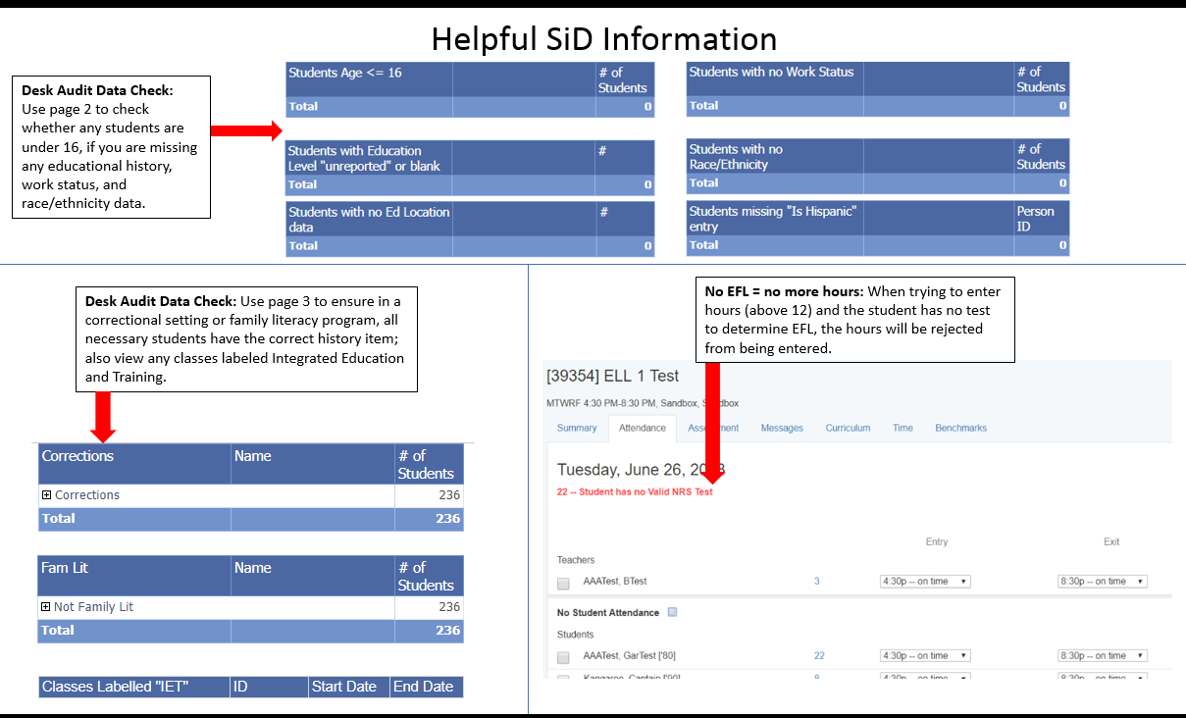

ABE Accountability 101: Helpful Links
Minnesota Adult Basic Education (ABE) main website: www.mnabe.org
SiD support articles and information: https://mnabe.zendesk.com/hc/en-us
SiD Login: www.sid.mnabe.org
Minnesota ABE Assessment: www.mnabeassessment.com
Minnesota Department of Education (MDE): https://education.mn.gov/MDE/index.html
- MDE ABE main page: https://education.mn.gov/MDE/fam/abe/
- Licensing: https://education.mn.gov/MDE/lic/
- Graduation Requirements: https://education.mn.gov/MDE/fam/grad/
- Data Center: https://education.mn.gov/MDE/Data/
- Maps: https://education.mn.gov/Maps/ABE/
National Reporting System (NRS): https://www.nrsweb.org/
GED Testing Service: https://ged.com/
TABE: http://tabetest.com/
CASAS: https://www.casas.org/
BEST PLUS: http://www.cal.org/aea/bp/

MN ABE Support Network (Supplemental Service Providers)
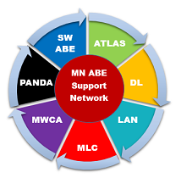
Serving students with disabilities – PANDA (mn.abedisabilities.org)
Professional development opportunities – ATLAS (atlasABE.org)
MN ABE's professional organization – Literacy Action Network (literacyactionnetwork.org)
Training on assessments – SW ABE (mnabeassessment.com)
How to utilize volunteers – MN Literacy Council (mnliteracy.org)
Integrating technology – MN Literacy Council (mnliteracy.org)

