Minnesota ABE Accountability 101
Version: August 9, 2019
- Welcome to WIOA
- The 6 Accountability Measures
- Measurable Skill Gain
- Interpreting the Educational Functioning Level Descriptors
- NRS Test Approval
- Data Management
- Showing Success (Targets, Report Cards and Program Improvement)
- Local Changes, Ideas and Questions

Welcome to WIOA
WIOA stands for the Workforce Innovation and Opportunity Act of 2014. It is a federal law that governs workforce development programs, including Adult Basic Education, the CareerForce Centers, and Vocational Rehabilitation.
Law Title (Section) | Name | Program/Activities | Who oversees in Minnesota
Title I (Subtitle A) | Workforce Development Activities (System Alignment) | All WIOA Programs | DEED and MDE
Title I (Subtitle B) | Workforce Development Activities (Workforce Activities and Providers) | Adult, Youth, and Dislocated Worker Programs | DEED
Title II | Adult Education and Family Literacy Act (AEFLA) | Adult Basic Education | MDE
Title III | Wagner-Peysar Act | CareerForce Centers (One-Stops) | DEED
Title IV | Rehabilitation Act | Vocational Rehabilitation (VR) | DEED
Title V | General Provisions | All WIOA Programs | DEED and MDE

Adult Education (WIOA Definition)
Academic instruction and education services below the postsecondary level that increase an individual’s ability to:
- Read, write, and speak in English and perform mathematics or other activities necessary for the attainment of a secondary school diploma or its recognized equivalent;
- Transition to postsecondary education and training; AND
- Obtain employment.
(Source: WIOA Section 203)

Federal Adult Education and Literacy Programs, Activities and Services
- Adult education,
- Literacy,
- Workplace adult education and literacy activities,
- Family literacy activities,
- English language acquisition activities,
- Integrated English literacy and civics education,
- Workforce preparation activities, or
- Integrated education and training.
(Source: Code of Federal Regulations, or CFR, §463.30)

English Language Acquisition Program (Definition)
A program of instruction—
(a) That is designed to help eligible individuals who are English language learners achieve competence in reading, writing, speaking, and comprehension of the English language; and
(b) That leads to—
(i) Both: (1) Attainment of a secondary school diploma or its recognized equivalent; and (2) Transition to postsecondary education and training; or
(ii) Employment.
(Source: Code of Federal Regulations §463.31)
How does an English language acquisition program prove it leads to attainment of a secondary school diploma, G.E.D., postsecondary education, training or employment?
Options:
- Have implemented State adult education content standards in curriculum, lesson plans, or instructional materials; or
- Offer educational and career advising that help students transition to postsecondary education or employment; or
- Be part of a career pathway.
(Source: Federal Regulations Citation (CFR §463.32))

Workforce Preparation Activities (Definition)
- Activities, programs, or services designed to help an individual acquire a combination of basic academic, critical thinking, digital literacy, and self-management skills
- Includes competencies in utilizing resources and using information, and acquiring other skills necessary for successful transition into postsecondary education, training, or employment
Connections with ACES Transitions Integration Framework

Integrated English Literacy and Civics Education-IELCE (Definition)
Provides instruction in:
- Literacy and English language acquisition,
- Civic participation and the rights and responsibilities of citizens,
- Workforce preparation and
- Workforce training
Activities must be provided in combination with IET activities.
Focuses program design and goal on preparing adults for employment in in-demand industries and in coordination with local workforce system.

Integrated Education and Training-IET (Definition)
Service approach that provides adult education and literacy activities concurrently and contextually with workforce preparation activities and workforce training that targets training for a specific occupation or cluster that assist adults in their educational and career advancement.
IET must be part of a career pathway. A career pathway is a combination of rigorous and high-quality education, training and other services that:
- Aligns with skill needs of the state’s or regional industries,
- Prepares an individual to be successful in a range of sec. or post-sec. education,
- Includes counseling to support an individual’s education and career goals,
- Includes education offered concurrently and contextually with workforce preparation and training in a specific occupation or cluster,
- Organizes education, training and other services to meet and accelerate an individual’s educational and career advancement,
- Enables an individual to attain a secondary school diploma or its recognized equivalent, and
- Helps an individual enter or advance within specific occupation or occupational cluster.

Participants with Barriers to Employment
ABE programs must ask enrollees if they identify with any of the following federally-defined barriers to employment:
- Displaced homemakers
- English language learners, low literacy levels, cultural barriers
- Exhausting TANF (MFIP) within two years
- Ex-offenders
- Homeless/runaway youth
- Long-term unemployed
- Low income
- Migrants and seasonal farmworkers
- Individuals with disabilities
- Single parents
- Youth in foster care/aged out of system
These should be marked in the student’s file in SiD (Minnesota state ABE database).

Federally-defined program exit
A federally-defined program exit occurs when the participant has not received services for the past 90 days and has no additional services scheduled. The date of exit is the last date on which the participant receives services. However, the exit date service cannot be determined until at least 90 days have elapsed since the participant last received services. This is automatically calculated and determined by SiD.
We do expect programs to exit students from classes in SiD when they are no longer attending.

Six Accountability Measures
WIOA outlines six different accountability measures for ABE programs and other WIOA title programs:
- Measurable skill gain
- Employment at second quarter after exit*
- Employment at fourth quarter after exit*
- Median quarterly earnings at second quarter after exit*
- Credential earned (and Entering Postsecondary or Employment)*
- Employer engagement**
Aggregated performance outcomes analyzed statewide, by consortium, by category of individuals facing barriers to employment, and by age, gender, and race.
* The Minnesota Department of Education is already measuring and reporting these numbers statewide. There may be federal targets for these measures starting in 2020.
**This measure is not yet being measured for ABE programs.

Minnesota ABE’s WIOA Outcomes
Measure | Statewide Report (2018) | Source
Measurable skill gain | 39.73% | SiD, MN State
Employment at second quarter after exit | 33.87% | DEED
Employment at fourth quarter after exit | 33.44% (partial) | DEED
Median quarterly earnings at second quarter after exit | $5,583 | DEED
Credential earned (and Entering Postsecondary or Employment) | 12.4% | SiD, MN State, DEED

Credential Attainment Measure Details
Percentage of participants who:
- Earn a high school or equivalency diploma (and was ABE Level 5+) or a recognized postsecondary credential (may be in IET program);
- Exits the ABE program;
- AND is employed or enrolled in a postsecondary education or training program within one year of exit.

Measurable Skill Gain
Federal Definition: The percentage of participants who, during a program year, are in an education or training program that leads to a recognized postsecondary credential or employment and who are achieving measurable skill gains, defined as academic, technical, occupational, or other forms of progress, towards such a credential or employment.

For ABE programs Potentially for IET programs
Multiple Ways to Count Measurable Skill Gain (MSG)
(Only one type of gain will be counted for each participant per period)
1. Earn higher scores on approved pre- and post-tests to advance to a higher level
2. Earn a secondary credential (high school or equivalency diploma) by June 30
3. Enter postsecondary education (only after participant exits ABE) by June 30
4. Participants in “adult high school” can complete Adult Basic Education
(ABE) Level 5 by earning enough Carnegie Units or credits to move to 11th- or 12th-grade status*
(*Not yet applicable for ABE in Minnesota)

Track Work-Focused Credentials Earned in SiD
ABE programs, especially those doing IET and career pathway programs, should be marking which work-focused credentials their students are earning. Here is a list of what industry-recognized credentials are currently in SiD:
- Minnesota Certified Food Manager
- Job Ready Assessment - Culinary Arts Level One- Prep Cook
- Carpenter Level One
- OSHA 10-hour Construction Certification
- OSHA 10-hour General Industry Certification
- Internet & Computing Core (IC3) Digital Literacy Certification
- Microsoft Office Specialist (MOS) Certification - Microsoft Office Word 2016
- Microsoft Office Specialist (MOS) Certification - Microsoft Office Excel 2016
- Microsoft Office Specialist (MOS) Certification - Microsoft Office Powerpoint 2016
- Microsoft Office Specialist (MOS) Certification - Microsoft Office Word 2013
- Microsoft Office Specialist (MOS) Certification - Microsoft Office Excel 2013
- Microsoft Office Specialist (MOS) Certification - Microsoft Office Powerpoint 2013
- Child Development Associate (CDA) Credential
- ParaPro Assessment
- Nursing Assistant Registered /Certified Nursing Assistant
- Home Health Aide
- Personal Care Assistant
- Phlebotomy Technician Certification
- The Community Interpreter: The International Edition (TCII)
- ServSafe Food Handler Certification
- Servsafe Food Protection Manager Safety Certification
- A+ Certification
- IT Fundamentals Certification
- Emergency Medical Technician (EMT) Basic Certification
- NIMS Credential - Machining Level 1 - Measurement, Materials, & Safety
- AWS Certified Welder
- AWS Robotics
- IPC-A-610, Acceptability of Electronic Assemblies
- Job Ready Assessment - Retail Merchandising
- RISE UP-Retail Industry Fundamentals
- First Aid and CPR/AED - Bloodborne Pathogens Training

Interpreting the Educational Functioning Level Descriptors
ABE | ESL
1 (Beginning ABE Literacy) | 1 (Beginning ESL Literacy)
2 (Beginning Basic Education) | 2 (Low Beginning ESL)
3 (Low Intermediate ABE) | 3 (High Beginning ESL)
4 (High Intermediate ABE) | 4 (Low Intermediate ESL)
5 (Low Adult Secondary) | 5 (High Intermediate ESL)
6 (High Adult Secondary) | 6 (Advanced ESL)

NRS Test Approval
Currently approved tests for Minnesota ABE programs:
- BEST Plus
- CASAS
- TABE

BEST Plus
For Levels: ESL 1-6
Name/Series | Content | Format | Forms/Levels
Basic English Skills Test (BEST) Plus 2.0 | ESL* | Paper-based,  Computer-adaptive | D, E, F
*Approved by OCTAE and the Minnesota Department of Education for NRS purposes through February 2, 2021.

CASAS
For Levels: ABE 1-6
Name/Series | Content | Format | Forms/Levels
GOALS | Reading | Paper-based, Computer-based | 901R-908R
GOALS | Math | Paper-based, Computer-based | 900, 913, 914, 917, 918
- Computer and paper versions (hand score or scanned using TOPSpro Enterprise)
- 2 Subjects: Reading and Math
- 4 Levels: A, B, C, D
- Math test has been submitted for review
- CASAS Life and Work Reading and Life Skills Math were dropped from the approved list for ABE Levels on June 30, 2019
For Levels: ESL 1-6
Name/Series | Content | Format | Forms/Levels
Beginning Literacy | Reading* | Computer-based,  Paper-based | 27 and 28
Life and Work | Reading* | Computer-based,  Paper-based | - Level A: 81, 82, 81X, 82X  - Level B: 83, 84  - Level C: 85, 86, 185, 186  - Level D: 187, 188
Life and Work | Listening* | Computer-based,  Paper-based | 981L-986L
*Approved by OCTAE and the Minnesota Department of Education for NRS purposes for ESL Levels through February 2, 2021.

TABE
For Levels: ABE 1-6
Name/Series | Content | Format | Forms/Levels
11 and 12 | - Reading  - Math  - Language | Computer-based  Paper-based | L: Literacy  E: Easy  M: Medium  D: Difficult  A: Advanced
- Computer and paper versions (hand score or scanned using DRC INSIGHT)
- 3 Subject Tests: Reading, Math, Language
- 5 Level Tests in each subject: L, E, M, D, A
- Each test has only 1 option (no survey)
- TABE 9 and 10 were dropped from the approved list on June 30, 2019

Awkward Test Transitions
- July 1, 2019: All ABE programs need to use only TABE 11/12 and/or CASAS GOALS for ABE level students
- CASAS Life and Work is valid for ESL-level students but not for ABE-level students.
- Publishers submitted CASAS GOALS and TABE CLAS-E ESL tests for approval to U.S. Department of Education. Neither approved yet. CASAS GOALS Reading will be resubmitted Fall 2020 for ESL levels.
- Currently approved (old) tests for ESL levels approved through 2021 (CASAS Life & Work Reading, BEST Plus)

Reference: ABE Assessment Policy
Found Online at: www.mnabe.org/abe-law-policy/mn-abe-policies
Look for:
- Which tests are approved for which levels
- Test training/certification requirements
  - People administering tests need to participate in certification training at least once every 5 years.
- Educational Functioning Level Descriptors
  - Please note that the revised Educational Functioning Level Descriptors for ESL levels 1-6 are not included since there are no approved tests for the new ESL descriptors yet.

Data Management
- SiD is the required state ABE database in Minnesota.
- SiD is an ABE program management tool specifically designed for the needs of Minnesota ABE.
- All Minnesota ABE programs are required to use SiD to enter student and program information.
- SiD data is used for creating federal, state and local reports.
- Many programs give all of their ABE staff access to SiD to either enter data or view data
- SiD has reports and tools for you to monitor your data.

12 Hour/No Pretest Lock
Limit on entering hours for students with No EFL
- Users cannot enter student hours past the 12 hour mark for students who have no EFL.
- Users cannot enter student hours past the 30 hour mark for Conditional Work Referral students.
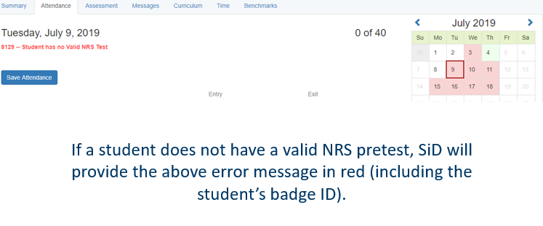

3 Month Rolling Lock
3 month rolling lock on student hours and test data entry
- Data entry and editing of hours and tests that are 3 months old (and older) will be blocked. An error message will appear when old hour and test score data entry or edit is attempted.
- If a program finds unentered or incorrect hours/tests, contact SiD Support for assistance.
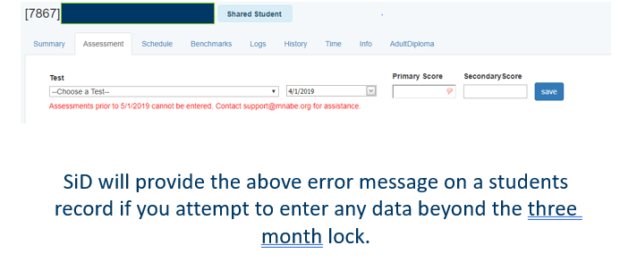

Annual ABE Program Data Check Points
All October-April data reviewed by June 1
- Programs submit reports via SERVS (Due 6/1)
All May-June data reviewed by July 31
- Programs email reports to Cherie (Due 8/1)
All July-September data checked by November 1
- No program submission to MDE
(MDE pulls and matches data at each due date)

Review and Analysis
- Make sure you are checking the Desk Audit Data Check at least quarterly and before any data deadlines as part of your local monitoring!

Desk Audit Data Check – Page 1
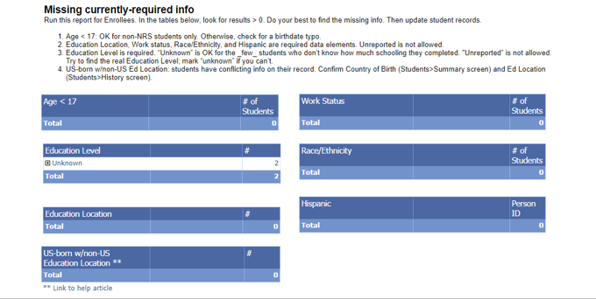

Desk Audit Data Check – Page 2
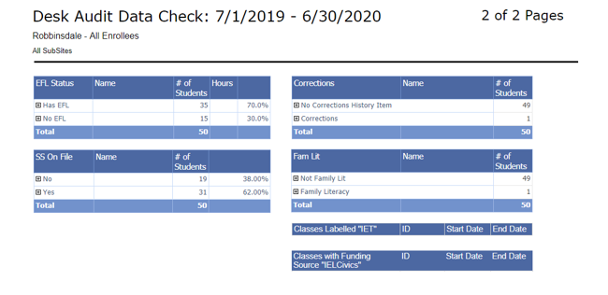

Showing Success (Targets, Report Cards and Program Improvement)

Statewide ABE System Annual Contact Hours
 | 2012-13 | 2013-14 | 2014-15 | 2015-16 | 2016-17 | 2017-18 | 2018-19
Contact Hours | 5,931,207 | 5,607,747 | 5,571,307 | 5,497,385 | 5,302,063 | 4,930,157 | 4,465,601
Growth from prior year | -0.4% | -5.5% | -0.6% | -1.3% | -3.6% | -7.0% | -10.6%

ABE Funding Contact Hour Rates for 2019-20
Contact hour rates have increased recently, mainly due to ongoing statewide decline of contact hours.
Rate | 2017-18 | 2018-19 | 2019-20
State | $6.05 | $6.50 | $7.30
Federal | $0.52 | $0.61 | $0.73
Note: Rates rounded to the nearest cent.

Minnesota ABE Core Federal Performance Targets
Targets for Measurable Skill Gain (MSG)
NRS Educational Functioning Level and Core Indicator Goals | MN FY 2017  (2016-17) |  |  | FY 2019  (2018-19) | FY 2020  (2019-20)
 | % Completing Each Level/Goal |  |  | % Earning Measurable Skill Gain | % Earning Measurable Skill Gain
 | Target | MN Actual | U.S. Actual | Target | Target
ALL ABE LEVELS |  |  |  | 43% | 44%
ABE 1: ABE Beginning Literacy | 78% | 60% | 48% | 61% | 61%
ABE 2: ABE Beginning Basic Education | 67% | 48% | 45% | 48% | 48%
ABE 3: ABE Intermediate Low | 50% | 41% | 42% | 43% | 43%
ABE 4: ABE Intermediate High | 34% | 37% | 42% | 40% | 41%
ABE 5: Low Adult Secondary | 26% | 29% | 52% | 46% | 52%
ABE 6: High Adult Secondary | N/A** | 28% | 42% | 36%** | 42%**
ALL ESL LEVELS |  |  |  | 43% | 44%
ESL 1: ESL Beginning Literacy | 48% | 45% | 44% | 45% | 45%
ESL 2: ESL Beginning Low | 58% | 56% | 50% | 56% | 56%
ESL 3: ESL Beginning High | 51% | 46% | 50% | 47% | 51%
ESL 4: ESL Intermediate Low | 39% | 39% | 45% | 42% | 45%
ESL 5: ESL Intermediate High | 35% | 35% | 39% | 37% | 37%
ESL 6: ESL Advanced | 16% | 23% | 24% | 25% | 26%

* Starting with the 2016-2017 data, ABE data is slowly evolving to adhere to the new WIOA accountability system, which is slightly different than previous data measures. Full WIOA accountability expectations will be implemented by 2020.
**For ABE 6, the only way to earn a measurable skill gain is through completion of a high school or equivalency diploma or to exit ABE and enter postsecondary education and training.

ABE Report Card
The report card is a document that lists the performance of all Minnesota ABE consortia in:
- Revenue per participant
- ABE measurable skill gains
- ESL measurable skill gains
- Post-testing rates
- ABE retention and persistence
- ESL retention and persistence
The report card is typically released in late summer/early fall.

Program Improvement
Program Improvement is a process that helps ensure our statewide ABE system reaches federal ABE targets. There will be a Program Improvement process starting in fall 2019 based on 2018-2019 ABE consortia outcomes, documented on the ABE Report Card.

Program Improvement Flags
ABE consortia will be flagged for possible participation in Program Improvement if they fall below the Program Improvement Benchmarks on one or more of the three tables with benchmarks:
- Measurable Skill Gains – ABE students (if more than 30% below federal super-targets)
- Measurable Skill Gains – ESL students (if more than 30% below federal super-targets)
- Post-testing Rates (if less than 60% of participants with 40+ hours were post-tested)

Program Improvement Cohort Selection
From all ABE consortia flagged for possible participation in Program Improvement, a group of ABE consortia will be selected for participation in the Program Improvement Cohort. Factors that will be taken into consideration include:
- Total number of flagged consortia
- Participant numbers
- Unique circumstances (e.g. individual sites within a consortium?)
The Program Improvement Cohort group will participate in:
- Full-day workshop in fall (November 20, 2019)
- Site visit by state ABE staff
- Improvement planning
- Technical assistance from state ABE staff
Please see the ABE Program Improvement Policy at: http://www.mnabe.org/abe-law-policy/mn-abe-policies

ABE Accountability 101: Resources and Helpful Links
Minnesota Adult Basic Education (ABE) main website: www.mnabe.org
SiD support articles and information: https://mnabe.zendesk.com/hc/en-us
SiD Login: www.sid.mnabe.org
Minnesota ABE Assessment: www.mnabeassessment.com
Minnesota Department of Education (MDE): https://education.mn.gov
- MDE ABE main page: https://education.mn.gov/MDE/fam/abe/
- Graduation Requirements: https://education.mn.gov/MDE/fam/grad/
- Data Center: https://education.mn.gov/MDE/Data/
- Maps: https://education.mn.gov/Maps/ABE/
National Reporting System (NRS): https://www.nrsweb.org/
GED Testing Service: https://ged.com/
TABE: http://tabetest.com/
CASAS: https://www.casas.org/
BEST PLUS: http://www.cal.org/aea/bp/

MN ABE Support Network (Supplemental Service Providers)
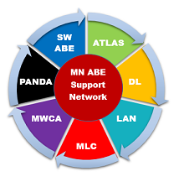
- Serving students with disabilities – PANDA (mn.abedisabilities.org)
- Professional development opportunities – ATLAS (atlasABE.org)
- MN ABE's professional organization – Literacy Action Network (literacyactionnetwork.org)
- Training on assessments – SW ABE (mnabeassessment.com)
- How to utilize volunteers – MN Literacy Council (mnliteracy.org)
- Integrating technology – MN Literacy Council (mnliteracy.org)

