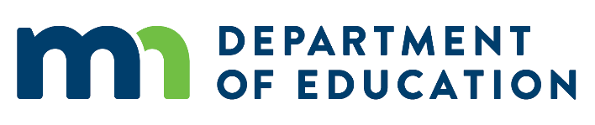
Minnesota Adult Basic Education (ABE)

Eligible Student Policy
Policy Development Date: April 12, 2013
Policy Implementation Date: July 1, 2013
Latest Policy Revision Date: February 6, 2019

Policy Overview

Background
Adult Basic Education (ABE) provides adults with educational opportunities to acquire and improve their literacy skills necessary to become self-sufficient and to participate effectively as productive workers, family members and citizens. The generic term of “ABE” in Minnesota includes several specific types of programs: basic academic skills, English language acquisition, high school equivalency assessment preparation, adult diploma, family literacy, and transition to postsecondary and careers.
Our state demographics document a clear need for adult education. More than 500,000 Minnesotans are eligible for ABE because they are at least 17 years old, are not enrolled in school, and have educational skills below the high school completion level. According to the American Community Survey of the U.S. Census, 10% (388,074) of Minnesotans over 18 years old lack a high school diploma or its equivalent. Additionally, the State Demographer’s Office estimates that one in ten Minnesotans over 5 years old speak a language other than English. One out every 15 workers in Minnesota is an immigrant or refugee.

Policy

Determining ABE Student Eligibility
An individual is eligible for ABE programming as an official ABE student if he/she is:
- At least 17 years of age; and
- Not enrolled in K-12 instruction; and
- Not required to be enrolled in K-12 instruction under state statute (see details below); and
- Who qualify under one or more of the following conditions:
  - Are unable to speak, read or write the English language;
  - Do not have a high school diploma or its recognized equivalent, and have not achieved an equivalent level of education;
  - Lack sufficient mastery of basic educational skills to enable the individual to function effectively in society.
ABE programs cannot enroll ineligible students as official ABE students generating contact hours for Table A for ABE grant funding.
Individuals are not eligible for ABE services if they are enrolled in a public or private K-12 program – this includes public or private regular high schools, charter schools, area learning centers, and other alternative or high school programs.
Students who are enrolled in postsecondary institutions are eligible for ABE services if they meet the conditions above. Please note the individual cannot be dually enrolled in a K-12 program (e.g. postsecondary enrollment option (PSEO), concurrent enrollment, or an early/middle college program).

Individuals Required to Be Enrolled in K-12
Minnesota State Statute 120A.22 details who must be enrolled in K-12 instruction.

For More Information
This policy, along with other ABE policies and resources, can be found online at the Minnesota ABE Law, Policy and Guidance page (http://www.mnabe.org/program-management/law-policy-guidance).
Minnesota state statutes and session laws can be found online at the Minnesota Office of the Revisor of Statutes website (www.revisor.mn.gov).
If you have any questions about the Minnesota ABE policies, contact Brad Hasskamp, (651) 582-8594 or brad.hasskamp@state.mn.us.

